Name of your Business

Site Plan

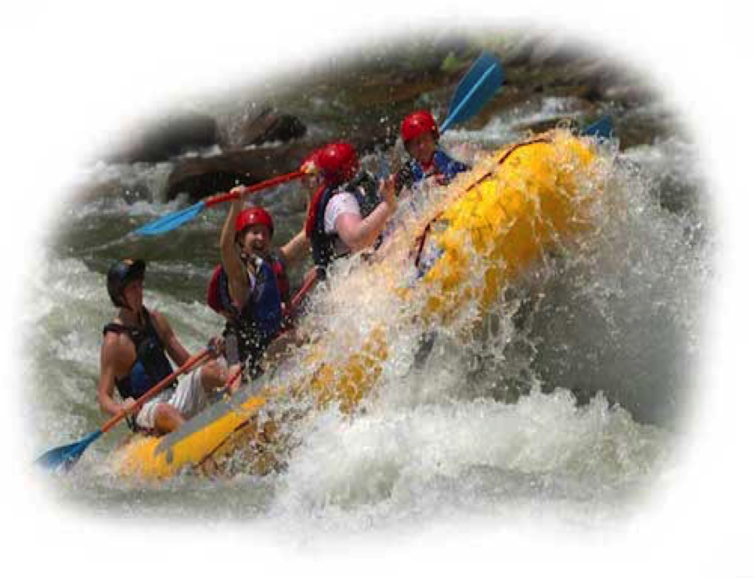

Firstname Lastname
WDD100-section

On the Title page, add your name and class number WDD100-03 or 04
Throughout the plan, the directions are in red. Read and fix each section, then delete the directions before submitting your site plan.
Overview

Site Purpose
[Place your purpose statement here that you wrote in week 2]

Target Audience
[Place your Audience definition here that you wrote in week 2]

Branding

Website Logo
You are not required to use this logo for your site…but you MUST have a logo for your website and here in your site plan Choose one of the ones in the images provided, or you can create your own ☺.



Color Palette
The colors you choose for a website are one of the most important decisions you will make. You will be choosing your color scheme using https://coolors.co/ . Export your colors as an image (or take a screenshot) and then upload your image to replace the color scheme you see below with yours. Also record the hex color codes (the 6 digit numbers that show when you hover over a color in your palette) for the colors you have chosen below. You should have at least 2 colors but do not have to fill in all 4 if you do not need them.


Primary | Secondary | Accent | Accent
#396E94 | #396E95 | #4E7C24F | #A43312

Replace the numbers in the boxes with your colors: hex or rob (I suggest hex)

Typography
Choose two fonts: one for your body copy and and another for your headlines. What font(s) have you chosen? Why did you choose what you did? Make sure to review the list of web safe fonts at W3Schools.org as a starting point. List your fonts here and tell why you chose them.

Heading and Paragraph Fonts
Now, show the fonts in action below: change the text below to match your headline styles (font family, color, size) and paragraph styles styles (font family, color, size).

<h1>The Whitewater Rafting Company of Colorado</h1>

<p>The best Whitewater Rafting in Colorado, White Water Rafting Company offers rafting on the Colorado and Roaring Fork Rivers in Glenwood Springs. Since 1974, we have been family owned and operated, rafting the Shoshone section of Glenwood Canyon and beyond. </p>

<p>Trips vary from mild and great for families, to trips exclusively for physically fit and experienced rafters. No matter what type of river adventures you are seeking, White Water Rafting Company can make it happen for you. We strive to make your fart trip the very best of your life. We pride ourselves on our 5-Star Tripadvisor rafting and our many other awards and accolades. </p>

<p>We are conveniently located an hour or less from Aspen, Snowmass, Eagle Avon, Beaver Creek, Vail, and Grand Junction.</p>

Navigation

Main Navigation
Describe your main navigation. Include the colors you would like for each state of the link (normal, hover, active, and visited). In the example table below ‘Home’ is showing what will happen when a link is in the hover state. The other boxes show the normal styling for the Navigation bar. You can modify the colors in the table below for a visual, create a visual in another program and add it as an image, or remove the table and just describe your navigation in text. Make sure to also change the colors below to color codes from your color scheme.

Home

Put the names of your other two pages in the blank boxes. Change the colors of the boxes to your colors. There are a list of possible pages with the site map on the next page.

Link:normal : #396E94
Link:hover : #E7C24F

Layout

Site Map
Home

The Site Map of a site is just like it sounds…it is a map of the pages in a site and how they are related and linked together.

From the map above we can see that we will eventually have the Home page and 2 sub or child pages.

The lines that connect them all together indicate that each page should be accessible from any other page, it is essentially showing us the global navigation for the site.

Put the pages that you will chose for the nav bar in the last section and put the names inside these two child page boxes… Some suggestions are below:

FAQ

Blog

Contact Us

Rivers We Run

Schedule/Rates/Dates

Wireframes
Wireframes are like blueprints for making webpages. They should show the major sections of content that will be on the page and the relative locations of each element. In the basic wireframe below you can see there will be 6 sections to our page:

At the top we have a section with the logo (the box with the mountain means an image) and the navigation bar. Then there is a banner image that stretches all the way across the screen. Next we have some text and an image followed by an image and some text. Then one more section of text with no image. Lastly, a footer containing a copyright/name line and the 3 social media icons you will use for your website.

Wireframes optionally can also contain information about element sizes as this one does. The 115x100 on the logo placeholder is telling you that it should be 115px x 100 px. The px stands for pixels…a common unit of measurement on the web.

